Task 4: Deploy a Linux Virtual Machine
What to do:
Deploy a VM with the following configuration:
Setting | Value
Image | Ubuntu Server 22.04 LTS
Size | Standard_B1s
Subnet | WebSubnet
Public IP | Yes (for testing — in production you'd use a load balancer)
Authentication | SSH public key (recommended) or password
Inbound ports | SSH (22) — for initial setup only
After the VM is deployed:
- SSH into the VM
- Install Nginx: sudo apt update && sudo apt install nginx -y
- Verify Nginx is running: sudo systemctl status nginx
- Open a browser and navigate to the VM's public IP — you should see the Nginx welcome page
Acceptance Criteria:
- VM is running with status "Running" in the Portal
- VM size is Standard_B1s
- VM is in WebSubnet
- Nginx welcome page loads in browser at the VM's public IP

Deploy a Linux Virtual Machine in Azure portal
- Sign in to the Azure portal.
- In the search box at the top of the portal, type Virtual Machine. Select Virtual Machine in the search results.
- Select + Create.
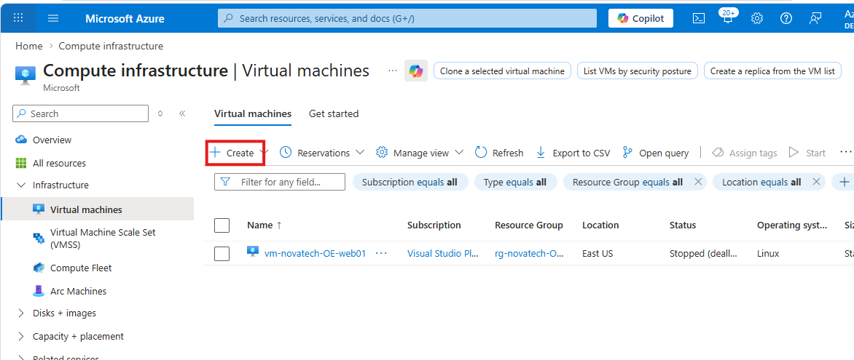

- Enter the following values:
- Subscription: Select your Azure subscription.
- Resource Group: Select the previously created RG
- Name: Give the Virtual machine a name.
- Region: Select an Azure location East US, same as the RG
- Availability zone: select the desired zone
- Image: select Ubuntu Server 22.04 LTS

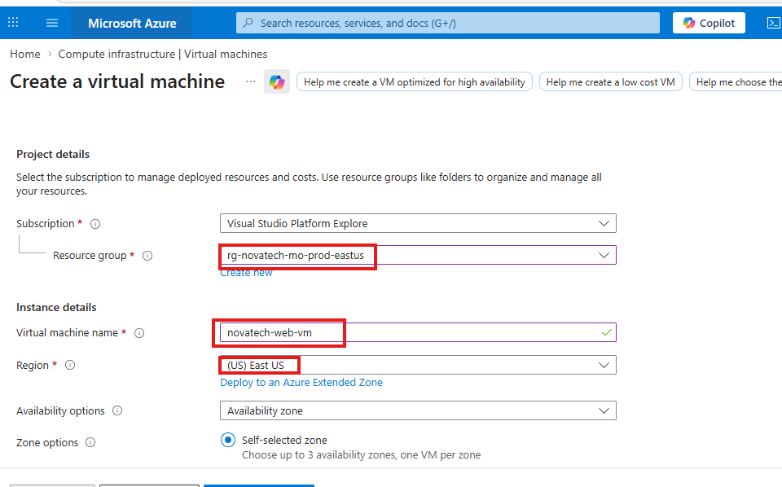

Availability zone: select the desired zone
Image: select Ubuntu Server 22.04 LTS
Size: Standard_B1s
Authentication type: will be using SSH public key
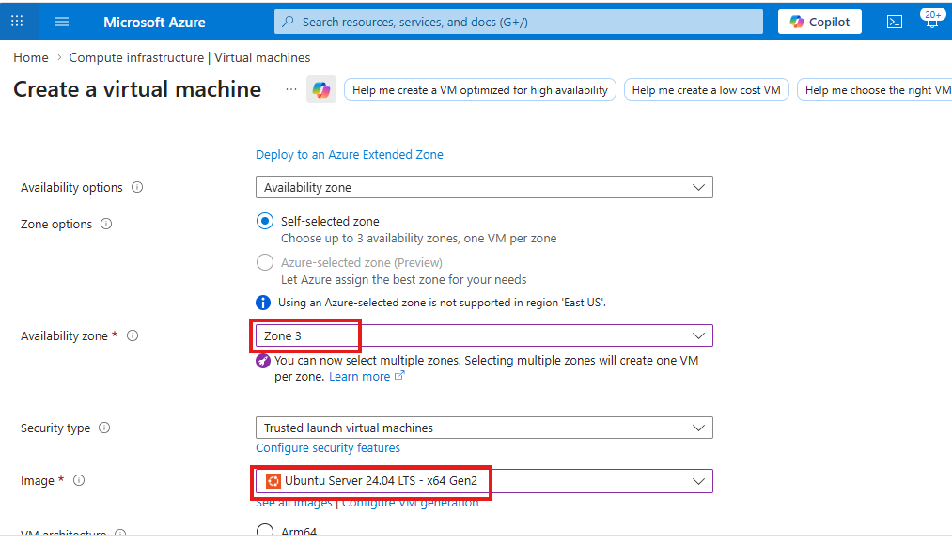

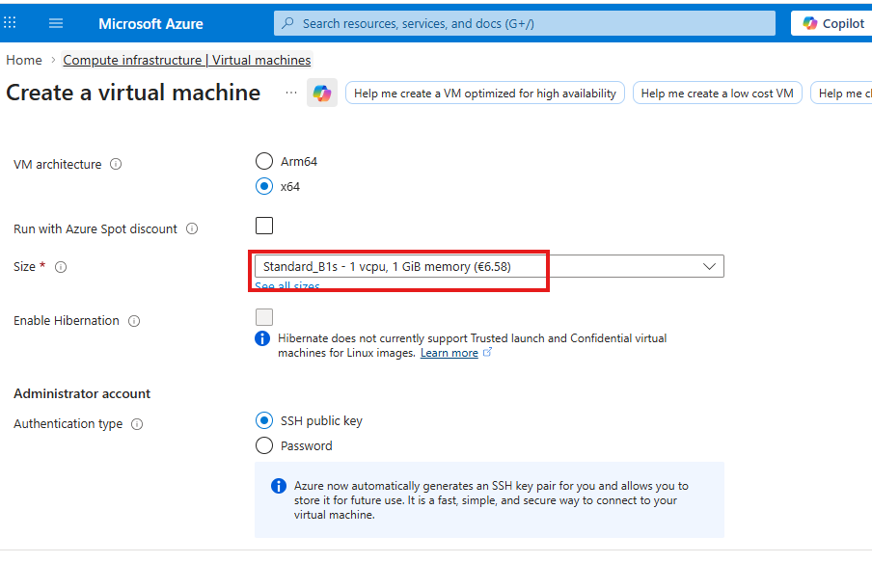
Selected port: SSH (22)
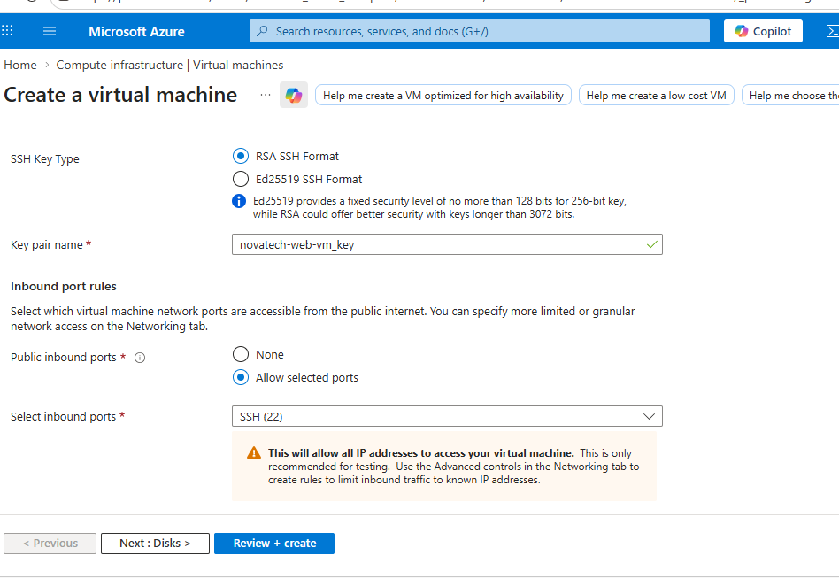

OS disk type: locally-reduntant storage
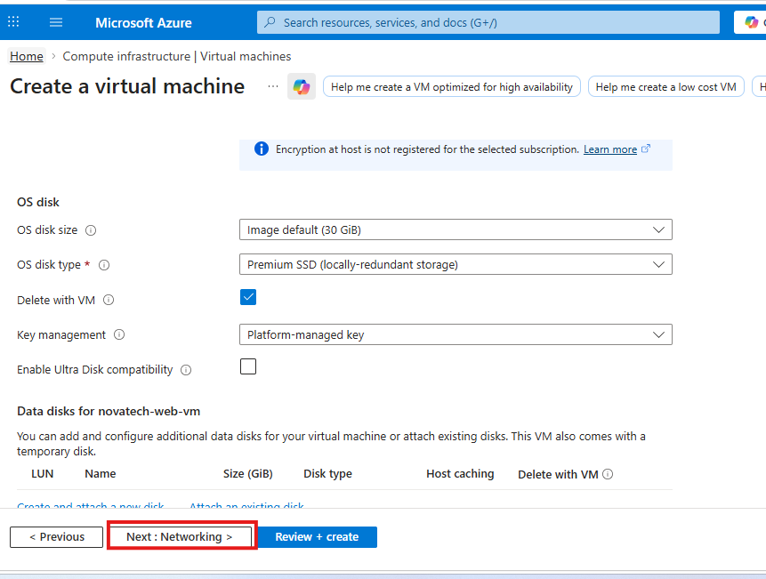
Virtual Network: Select the vnet previously created
Click on the drop-down arrow to select the previously created WebSubnet
Select Basic for the NIC network
Click on review + create to review and create the VM
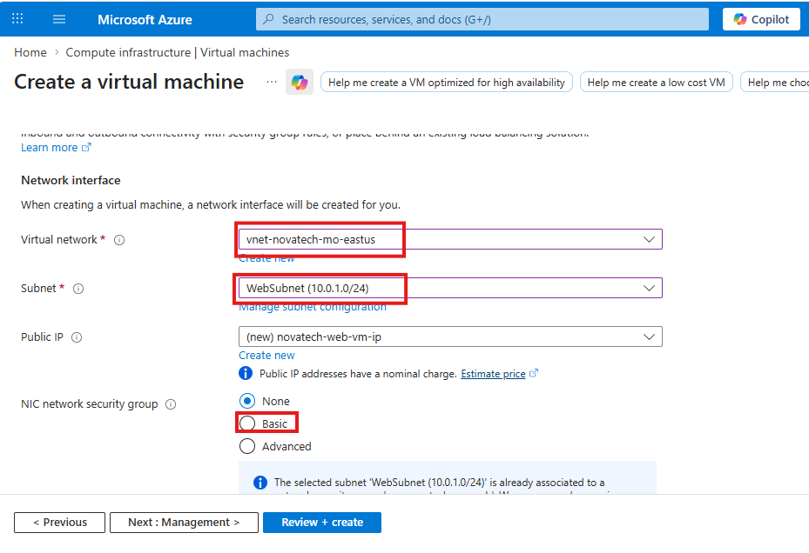
The VM has been created
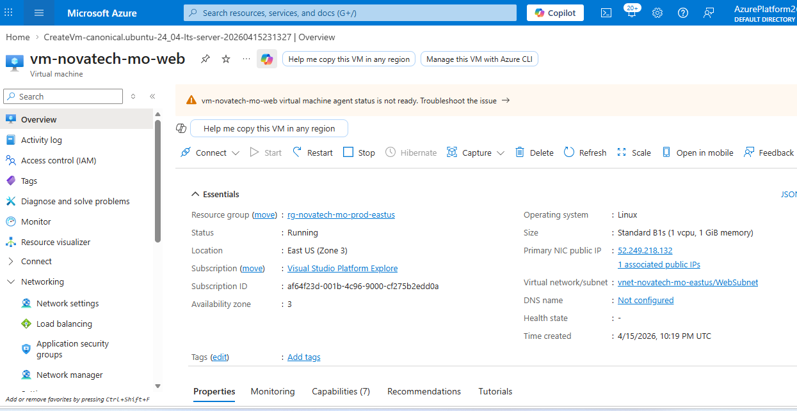
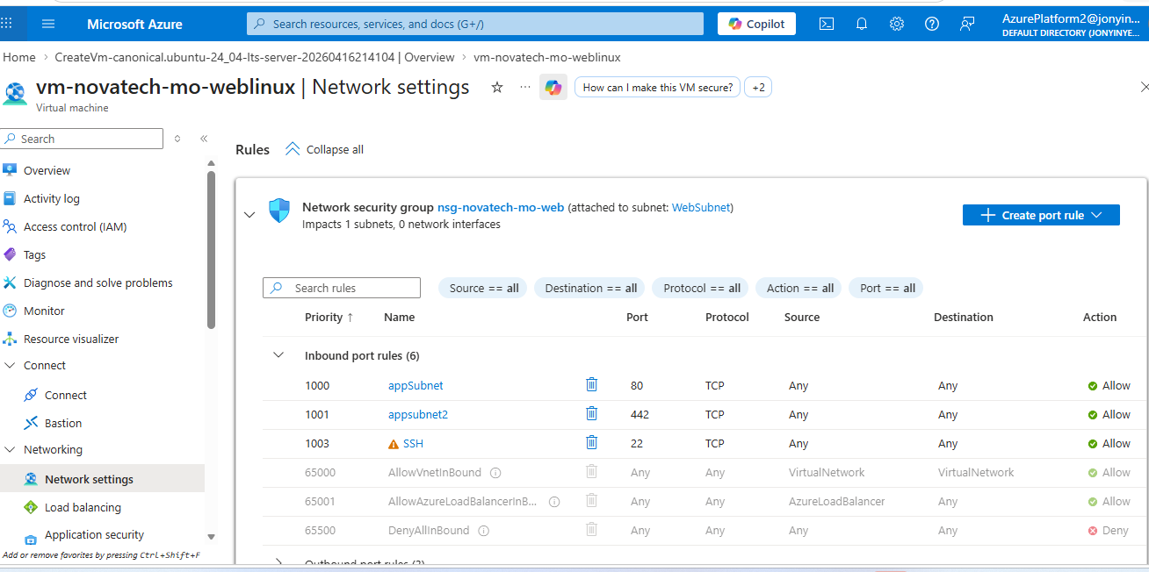

For authentication, I downloaded the SSH public key after the VM creation.
Run ssh -I <your-private-key-file> .pem azureuser@<your_public-ip> on Cloud Shell inside the Azure portal to connect as the root user.
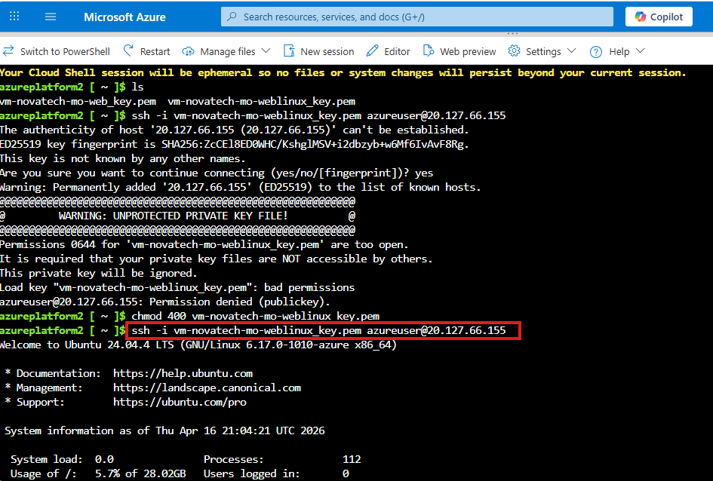
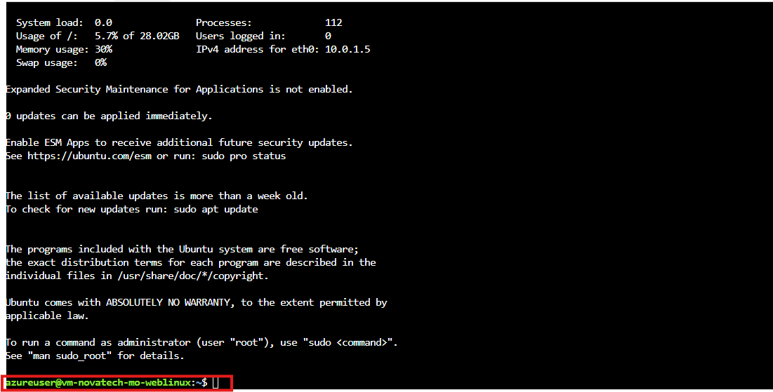

Install Nginx: sudo apt update && sudo apt install nginx -y
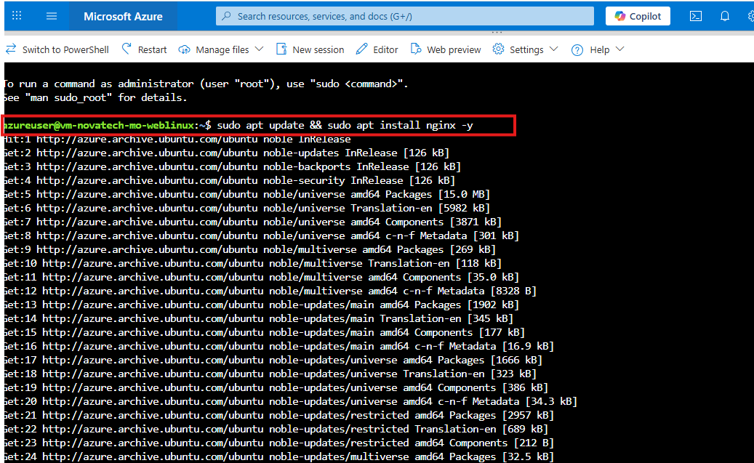

Verify Nginx is running: sudo systemctl status nginx
